2004-2005 TERM 1 IRELAND WEEK 3

FAITH
Bible RA (4 days at tea-time, breakfast or lunch)
New Catholic Picture Bible, chapters 8-11

Catechism
RA (3 days)
Prayer (Biffi) (pages 20-25)
Little Acts of Grace (pages 13-15)
K-1: (reading: 2 days; notebook: 5 days)
Image of God: chapter 3
New St. Joseph Catechism, book 0: page 64
Bible notebook: 4-5 pages

2: reading: 2 days; notebook: 1 day) Apostle's Creed
Faith and Life 2: chapter 31
New St. Joseph Catechism, book 0: page 64 Memorize and copy
Making Things Right: pages 5-7
First Communion notebook: "Creed"

3-5: (reading: 2 days; notebook: 1 day)
Faith and Life 4: chapter 4
New St. Joseph Catechism, book 1: chapter 3
Old Testament notebook: “God Prepares a People For the Savior”

6-8: (reading: 2 days; notebook: 1 day)
Faith and Life 6: chapter 6
New St. Joseph Catechism, book 2: chapter 3
Ten Commandments notebook: “Second Commandment”
Write out from scripture; write meaning in own words; illustrate; decorate

Saints
Read-Aloud (daily)
St. Therese and the Roses (Homan): pages 57-82, at tea-time

K-2: (1-2 days)
The Holy Twins: Benedict and Scholastica (Norris/dePaola)
Once Upon a Time Saints (Pochocki) (read at dinner)

3-5: (1-2 days)
Brendan the Navigator (Fritz): pages 17-21

6-8: (1-2 days)
Francis and Clare: Saints of Assisi (Homan): chapters 5-6

LITERATURE
Read-Aloud (daily)
Celtic Fairy Tales (Philip) (choose a story each day)
Darby O'Gill and the Good People (Kavanagh) (Section 3, chapter 2 to end) at bedtime

K: (Narrate and Illustrate each day)
Beginner's Bible (Henley), 4 stories (pages 78-104)

1-2: (daily)
Jamie O’Rourke and the Big Potato (dePaola) (prepare a puppet show for Irish Festival week 6)
Jamie O’Rourke and the Pooka (dePaola) (prepare a skit for Irish Festival week 6)

3-5: (daily) (any/all of above plus:)
Winding Valley Farm: Annie's Story (Pellowski) (First half: 7-29; 30-52; 53-70; 71-92)

6-8: (daily)
Francie on the Run (von Stockum) (chapters 1-7: 1-2; 3-4; 5; 6; 7)

DICTATION
K: Beginner's Bible, p. 82
One night, the king had a dream.
1-2: Jamie O'Rourke and the Big Potato
As he was pondering what to do, his neighbor passed by on his way to the village.
3-5: Winding Valley Farm, p. 50
They all rode back on the top of the hay rack, laughing and giggling. Then it was time to do all the chores: carry in wood, feed the chickens, geese and pigs, get the cows, start the supper.
6-8: Francie on the Run, p. 78
The afternoon lay heavy on the land. Hills shimmered in the distance and flowers closed their tender faces against the light. The sun's rays lay like warm hands around Francie's head. What if none turned up today? Where would he sleep? He got tired of sitting and walked on a bit.

GRAMMAR
2-8: (1 day)
Simply Grammar, Lesson 3

HISTORY
Spines (4 days)
Story of the World 2, chapter 4
Child's History of the World, chapter 38
Usborne World History, pages 108-109, 127?
Website

Read-Aloud (daily)
Black Horses for the King (McCaffrey) (Parts One and Two: pages 3-23; 23-41; 41-65; 65-78; 78-93)

K-2: (2 days)
(check SOTW book for ideas; esp about Irish Potato Famine)
St. Nicholas (Whelan) and (Tompert)
The Legend of St. Christopher (Hodges)

3-5: (2-3 days)
Maps and Globes (Knowlton/Barton) pages 16-21

6-8: (2-3 days)
Augustine Came to Kent (Willard) (intro-chapter 6)

GEOGRAPHY
Read-Aloud
Ireland -- in Pictures (or see list)
Irish video "A Celtic Journey through Time"

Mapwork
Mark more monasteries on your world map. Where did the potato farmers live?

Time-line
Saint Patrick (AD385-461)
Saint Benedict (AD480-550)
Saint Scholastica (AD 480-543)
Saint Nicholas (4th century -- d. AD 380)
Irish Potato Famine (1845-1847)
Augustine of Canterbury (d. AD604)

SCIENCE
Read-Aloud
One Small Square: Backyard (Silver), 6-7 pages

HEALTH
Read-Aloud
I Read Signs (Hoban) (1/2)
Activity
Signs book, pages 6/8

NATURE STUDY
Nature Walk
Potatoes / food plants. What food staple plants grow nearby? (Corn) Visit a corn maze.
Nature Notebook
Draw your shamrock and potato plants. When large enough, label. Narrate about the importance of the potato plants to the Irish; especially during the famine.
Nature Study
Monitor your shamrock plants. Read about different varieties of potatoes and/or corn. Plant a potato.

MATH
K:
Miquon, math notebook, Math-It for drill
1-2:
Miquon, math notebook (see Singapore), Math-It for drill
3-5:
Miquon, math notebook (see Singapore), Math-It for drill
6-8:
Keys to …, math notebook??, Math-It for drill

NARRATIONS
K:
Bible story (4), Nature (1: Backyard Field Guide)
1-2:
Saints Benedict & Scholastica, Religion (Creed), History (1), Nature (1: BFG)
3-5:
Saints Benedict & Scholastica, Religion (God Prepares a People for the Savior), History (1), Nature (1: BFG)
6-8:
Saints Benedict & Scholastica, Religion (Second Commandment), History (1), Nature (1: BFG)

ART -- Fra Angelico
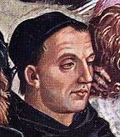
Biography
See websites: http://www.wga.hu/frames-e.html?/bio/a/angelico/biograph.html
Or continue with Book of Kells
Print “Annunciation”
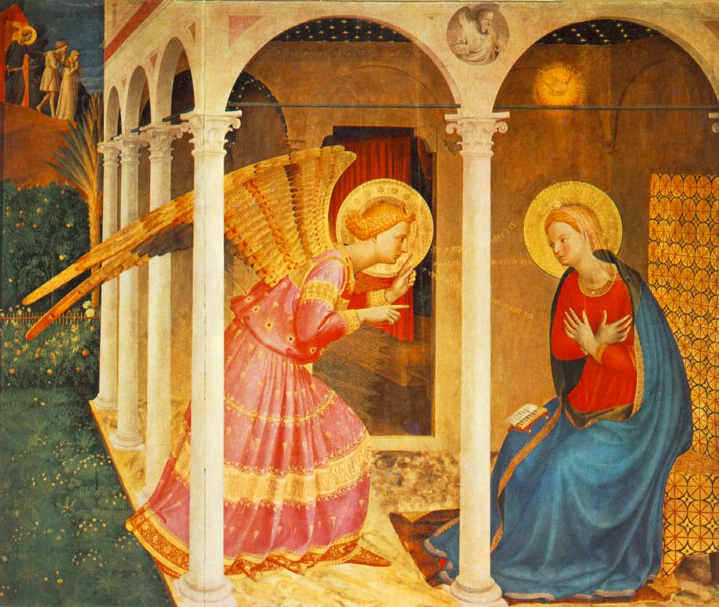
http://www.wga.hu/frames-e.html?/bio/a/angelico/biograph.html

1433-34
Tempera on wood, 150 x 180 cm
Museo Diocesano, Cortona
This altarpiece, called Cortona Altarpiece (to be distinguished from the Cortona Triptych) and consisting of the Annunciation and six small predella pictures, was executed for the church San Domenico at Cortona, and in later centuries, probably during the French occupation, was transferred to the church Gesu, presently the Museo diocesano.
The painting is a repetition of the main panel of the Prado Altarpiece in a more refined architectural setting.The altarpiece is the work of Fra Angelico with an intervention of his collaborators only in the predella pictures.

Artwork
Fra Angelico (Lloyd)
Hands-on
Step-by-Step Mosaics
MUSIC
Biography Irish Tenors website: http://www.thetenors.com/
CD
The Very Best of the Irish Tenors, 1999-2002

Hands-On
Tin whistles
Song: "Be Thou My Vision" Sing and play on tin whistles
Practice step and/or ceili dance

POETRY
Poem memorization
Saint Patrick's Breastplate:
Christ be with me, Christ within me;
Christ behind me, Christ before me,
Christ beside me, Christ to win me
Christ to comfort and restore me.

Christ beneath me, Christ above me,
Christ in quiet, Christ in danger,
Christ in hearts of all that love me,
Christ in mouth of friend and stranger.

Copywork
Copy above into poetry notebook. Decorate if desired.

ACTIVITIES
Cooking
Colcannon (Irish mashed potatoes and cabbage. I use skim milk and ricotta for a nonfat version.)
Videos
Lord of the Dance
A Celtic Journey Through Time

Crafts
Source: Crafts for St. Patrick's Day (Ross)
Potato puppet, pp. 8-9 construction paper, yarn
Make more puppets for Jamie O'Rourke and the Big Potato puppet show
SOTW Activity book 2
Code of Justinian
Paper dolls
Mosaic (+see step-by-step mosaics)
Secret Acts of Kindness

